26 Welsh words and phrases you'll definitely need when watching the rugby!

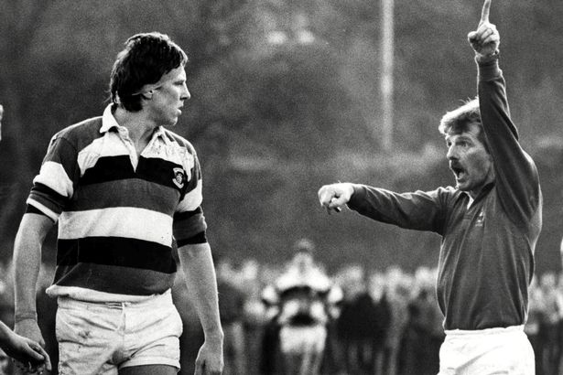
Add a whole new dimension to your ability to shout at the television/Welsh players/opponents with this handy guide from Pethau Bychain, the Welsh Government campaign encouraging more of us to use a little bit of Welsh every day

1. Ti’n ddall reff! You’re blind ref!

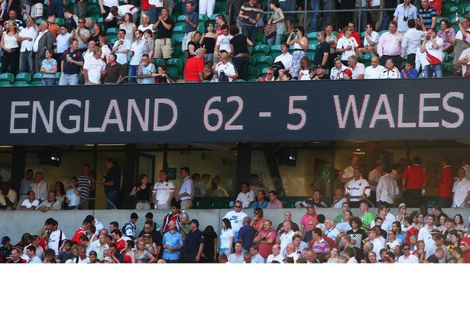
2. Beth yw’r sgôr? What’s the score?

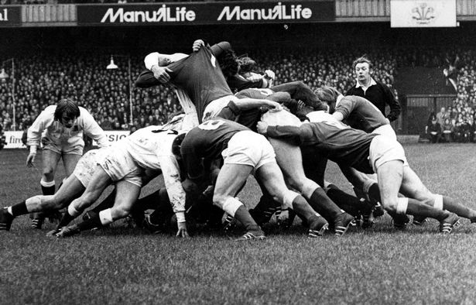
3. Sgrym Scrum

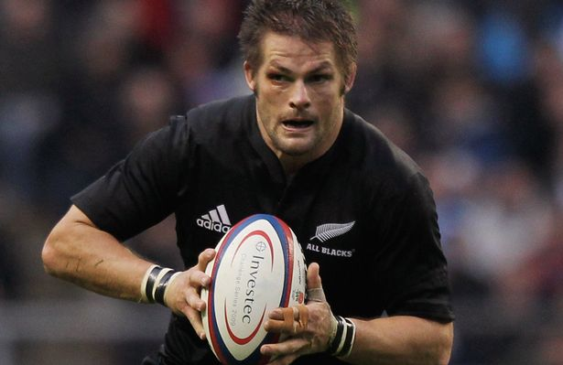
4. Troi’r bêl Turnover

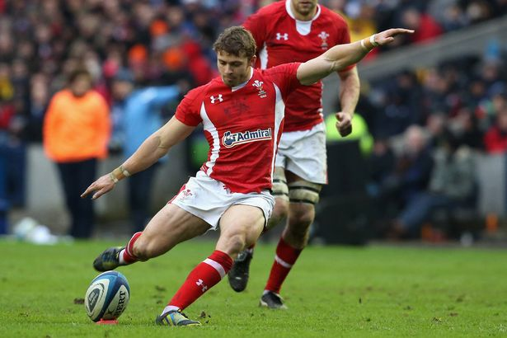

5. Cic gosb Penalty

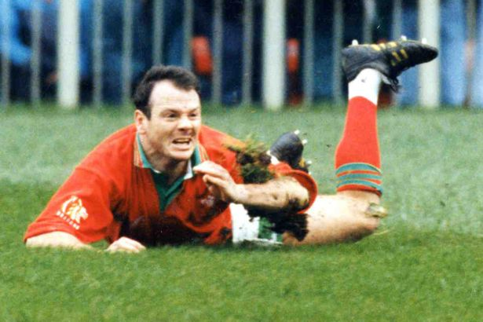

6. Cais Try

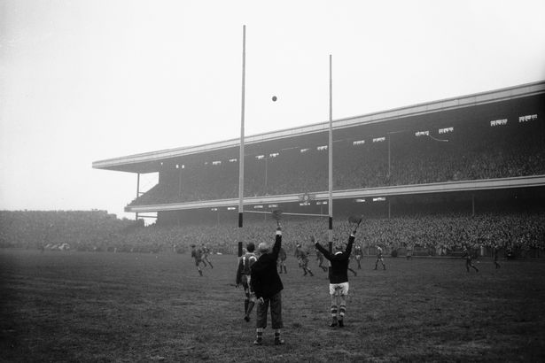
7.Trosiad conversion
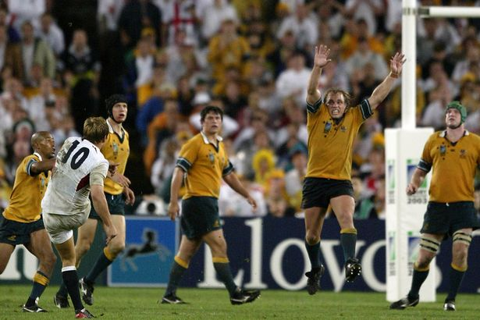

8. Cic adlam Drop kick

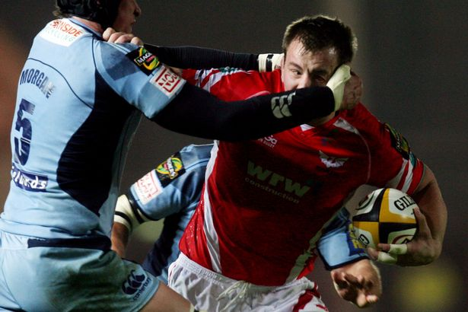

9. Tacl uchel High tackle

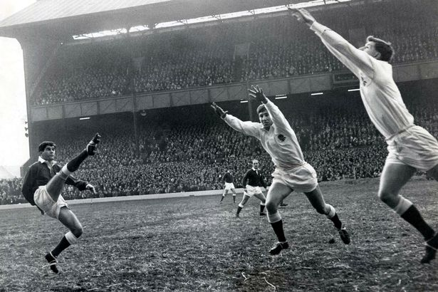

10. Camsefyll Offside

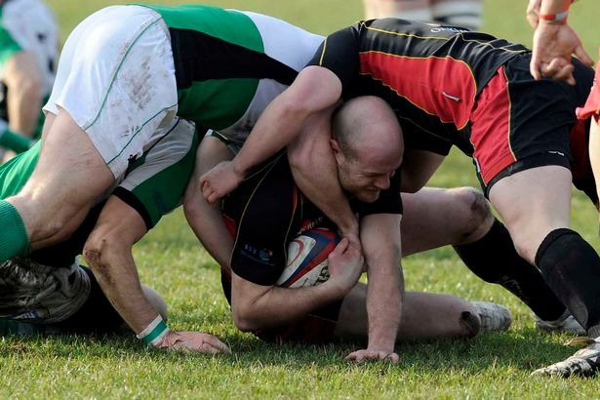
11. Mae’n dal ei afael! He’s holding on!

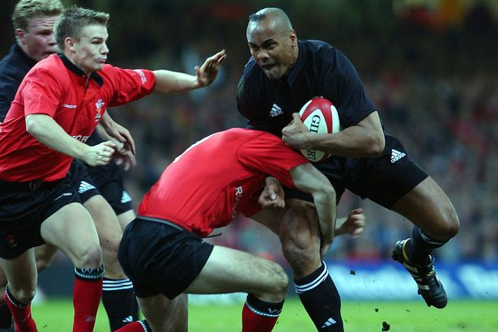
12. Lawr a fe! Get him down!

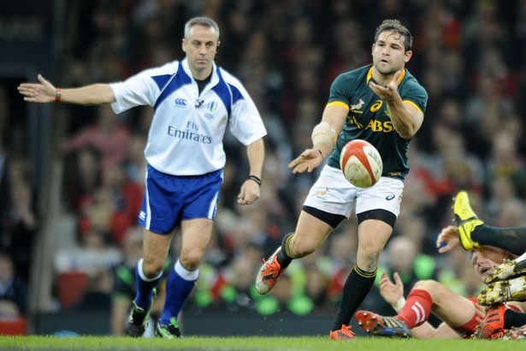
13.

Mantais Advantage

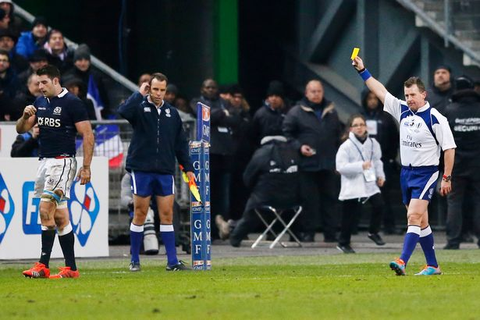
14. Cell gosb Sin bin

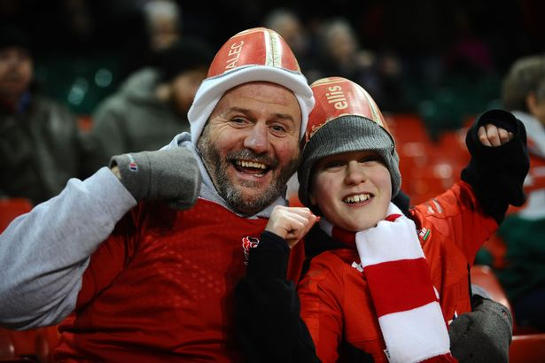
15. Dw i ar y bocs, mam! Mam, look, I’m on the telly!

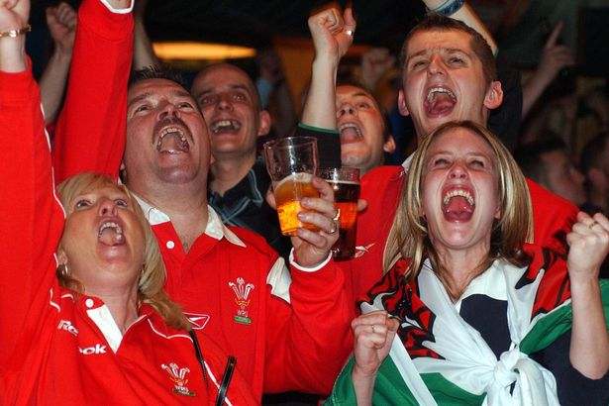
16. Dau beint o gwrw plîs Two pints of beer, please
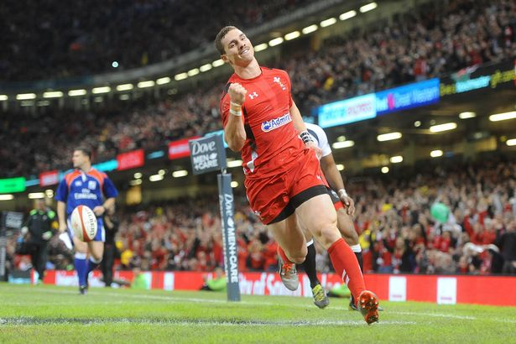
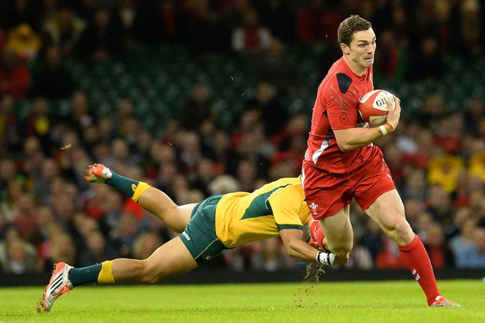
17. 'Shgwla’ ar i goese fe''Check out the thighs on him'

18. Pasia fe at George! Pass it to George!

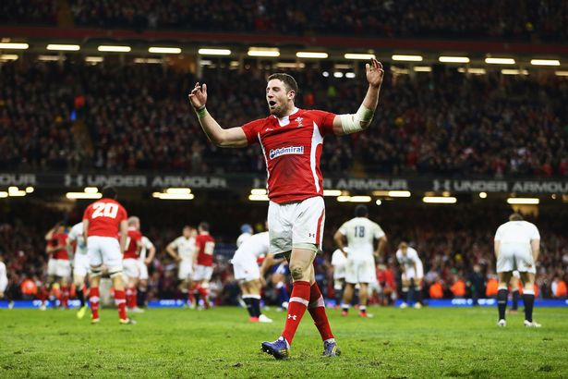
19.Maeddu’r Saeson sy’n bwysig As long as we beat the English, we don’t care

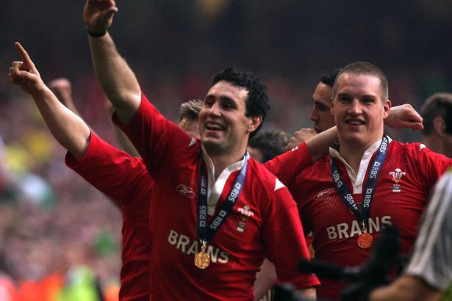
20. ’Da chi’n gwybod y ffordd i Caroline Street? Can you tell me the way to Caroline Street?

21. Camp Lawn Grand Slam
As seen in 2005. And 2008. And 2012. And very often in the 1970s.

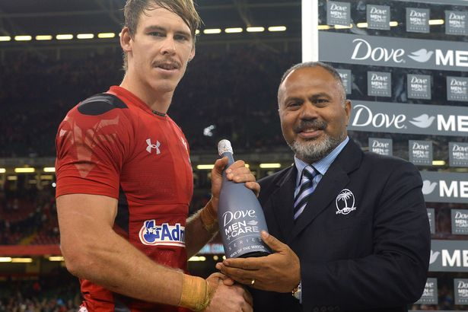
22. Seren y gêm Man of the match

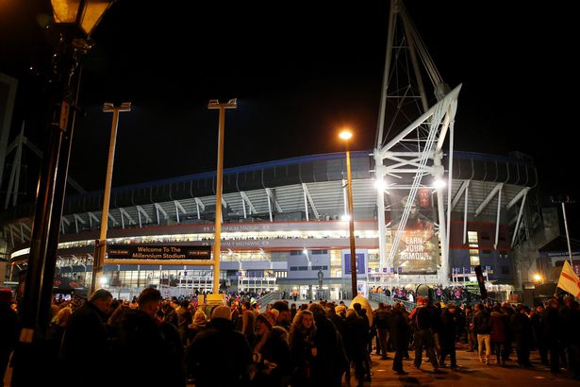
23. Stadiwm y Mileniwm Millennium Stadium

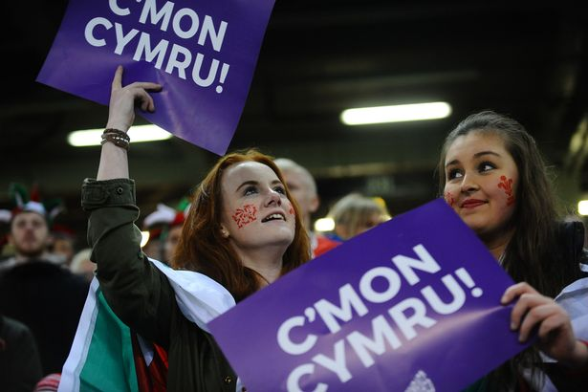
24. C’mon Cymru! C’mon Wales!

25. Os chi moyn cwtsio bois, gwnewch e gartre If you want a cwtch, boys, do it in your own time. (An all time Nigel classic)

26. Roedd y bàs ’na mor bell mlaen, ma’ i hanner ffordd drwy wythnos nesa! That pass was so forward it was halfway into next week

