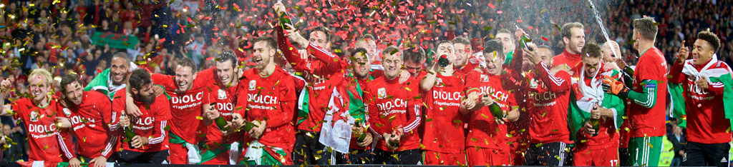
Gorau Chwarae Cyd Chwarae
Offside | Camsefyll  (Kam sev-ill) | Substitute | Eilydd  (Ay-lith)
Goalkeeper | Gôl-geidwad  (Gaul gay-dwad) | Foul | Trosedd  (Troh-seth)
Defender | Amddiffynnwr  (Am-thifun-whir) | Free kick | Cic rydd  (Kik reethe)
Midfielder | Canolwr  (Kanoloor) | Penalty kick | Cic o’r smotyn  (Kik orr smottin)
Striker | Blaenwr  (Bline-oor) | Manager | Rheolwr  (Rhee-oh-loor)
Yellow card | Cerdyn melyn  (Kerr-din melin) | Coach | Hyfforddwr  (Huh-fohr-thoor)
Red card | Cerdyn coch  (Kerr-din corchh) | Half time | Hanner amser  (Han-err am-sehr)
Gooooooooal! | Gôôôôôôl!  (pronounced ‘GAAAAAUL’) | I like your beard | Dwi’n hoffi dy farf di  (Dween hoff-ee duh varr-v dee)
How can I have hair like Ramsey? | Sut alla i gael gwallt fel Ramsey?  (Sit all-uh ee gile gwallt vel Ramsey?) | On a roll, now | Co ni off!  (Ko knee off)
Can you teach me to dance like Joe Ledley? | Alli di fy nysgu i i ddawnsio fel Joe Ledley?  (Alli dee vuh nuhsgee ee ee thawnseeo vel Joe Ledley) | Get out of here! | Cer o ’ma  (Ker-orr-mah)
Joe Allen is the Welsh Pirlo | Joe Allen yw’r Pirlo Cymreig  (Joe Allen ew-rrr Prilo Kum-rye-g) | Sing your heart out | Canu nerth eich pen  (Kanee nerrth aychh pen)
How tall is Wayne Hennessey? | Pa mor dal yw Wayne Hennessey?  (Pa moh-r dah-l ew Wayne Hennessey) | Another drink? | Diod arall?  (Dee-odd arall?)

